**PSFML Sessions 1&2 Homework**

**Full Name: _____________________________**

**Group No.: ____**

**Lecturer Name: ____________________**

**Submission date: _/_/__ Grade: __/25**

## Please write down all the steps not the final answer only

## Questions (25 points):

1. (3 points) A fair coin is tossed, and a fair die is thrown. Write down sample spaces for
2. the toss of the coin;
3. the throw of the die;
4. Let A be the event that a head is tossed, and B be the event that an odd number is thrown. Directly from the sample space, calculate P(A ∩ B) and P(A ∪ B).
5. (5 points) M&M candy are of varying colours and the different colours occur in different proportions. The table below gives the probability that a randomly chosen M&M has each colour, but the value for tan candies is missing:

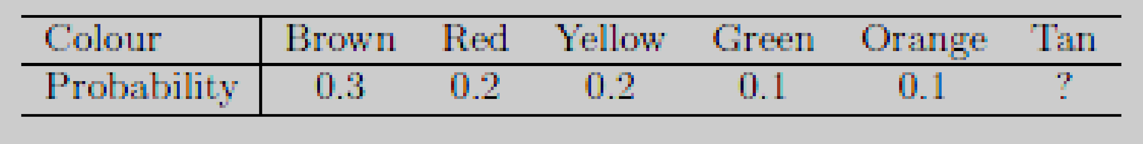

1. What value must the missing probability be?
2. You draw an M&M at random from a packet. What is the probability of each of the following events?
   * 1. You get a brown one or a red one.
     2. You don’t get a yellow one.
     3. You don’t get either an orange one or a tan one.
     4. You get one that is brown or red or yellow or green or orange or tan.
3. (2 point) Q and R are independent events. P(Q) = 0.4 and P(Q AND R) = 0.1. Find P(R).
4. (4 points) The following table shows a random sample of musicians and how they learned to play their instruments.

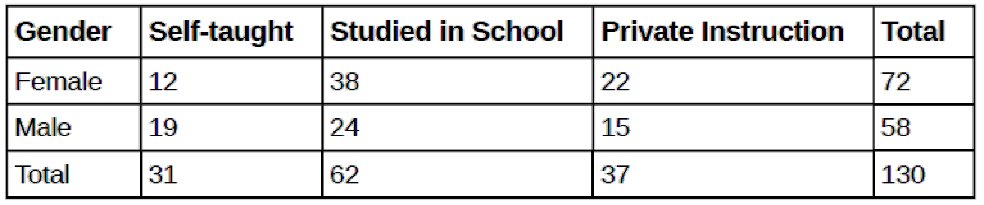

* + 1. Find P(musician is a female).
    2. Find P(musician is a male AND had private instruction).
    3. Find P(musician is a female OR is self taught).
    4. Are the events “being a female musician” and “learning music in school” mutually exclusive events?

1. (2 points) A men's soccer team plays soccer zero, one, or two days a week. The probability that they play zero days is 0.2, the probability that they play one day is 0.5, and the probability that they play two days is 0.3. Find the long-term average or expected value, *E(X)* or μ, of the number of days per week the men's soccer team plays soccer.
2. (2 points) Roll a **fair**, six-sided die **twice**. Let X = the number of faces that show an even number (total of two rolls). Calculate the mean μ and standard deviation σ of X.
3. (3 points) Let be a random variable 𝑋 with [𝑋] = 1 and 𝑣𝑎𝑟(𝑋) = 4. Find the following:
4. [2𝑋 − 4],
5. [$X^{2}$]
6. [${(2X - 4)}^{2}$].
7. (4 points) Let (𝑋, 𝑌) be the bivariate random variable with joint PMF (Probability Mass Function) given by:

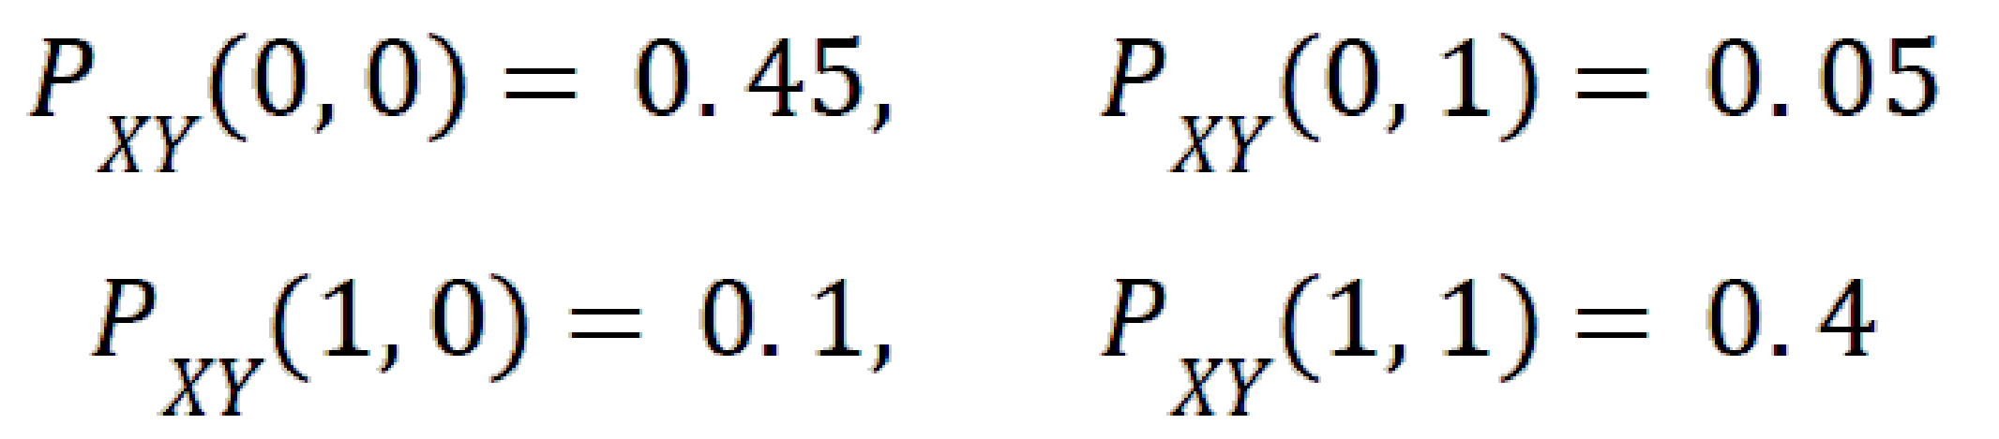

Find the following:

* 1. Find the marginal PMF’s of 𝑋 𝑎𝑛𝑑 𝑌
  2. Are 𝑋 𝑎𝑛𝑑 𝑌 independent?
  3. Find the mean and variance of 𝑋
  4. Find the mean and variance of 𝑌

## Readings:

* + Probability: <https://www.mathsisfun.com/data/probability.html>
  + Further Concepts in Probability: <https://www.wyzant.com/resources/lessons/math/statistics_and_probability/probability/further_concepts_in_probability>
  + Probability of events: <https://www.mathplanet.com/education/pre-algebra/probability-and-statistic/probability-of-events>
  + Permutations & combinations: <https://www.mathplanet.com/education/pre-algebra/probability-and-statistic/combinations-and-permutations>
  + Joint and marginal probability:
  + <https://www.statisticshowto.datasciencecentral.com/joint-probability-distribution/>
  + <http://homepage.stat.uiowa.edu/~rdecook/stat2020/notes/ch5_pt1.pdf>
  + <https://machinelearningmastery.com/how-to-calculate-joint-marginal-and-conditional-probability/>
  + Mean value/expected value/average E, Variance (Var), standard deviation (sigma)
  + <https://online.stat.psu.edu/stat500/lesson/3/3.2/3.2.1>
  + <https://towardsdatascience.com/essential-statistics-for-data-science-ml-4595ff07a1fa>
  + Covariance (matrix) /correlation (matrix): <https://machinelearningmastery.com/introduction-to-expected-value-variance-and-covariance/>
  + Covariance vs correlation: <https://www.surveygizmo.com/resources/blog/variance-covariance-correlation/>